How to use this tab
This tab holds the new material that has to be placed inside Tab 1 and inside the tab ‘latest version chapter 5 and 6’. The editing tool can change existing text but cannot place new headings, tables or figures in the middle of an existing tab, so these were built here, already formatted, and each one is marked as a numbered block. Every change that could be made in place was made in place as a suggestion, so it can be accepted or rejected in the normal way. A marker of the form [INSERT HERE: Block …] was left in the latest tab where Blocks B1 and C1 belong. Copy each block (from its heading or first paragraph to the end of its legend) and paste it at the place named in its pink note, then delete the note and the marker.
Inserting the new tables and figures changes the numbering of Chapter 6. The new items are Table 6.5 (final campaign), Table 6.8 (wormhole evidence), Tables 6.10 and 6.11 (verification of every run and replaced captures), Table 6.17 (final clustering), Figure 6.4 (wormhole tunnel), Figure 6.6 (verification map) and Figure 6.16 (final clustering). The existing tables are renumbered as follows: 6.5 to 6.6, 6.6 to 6.7, 6.7 to 6.9, 6.8 to 6.12, 6.9 to 6.13, 6.10 to 6.14, 6.11 to 6.15, 6.12 to 6.16 and 6.13 to 6.18; Tables 6.1 to 6.4 keep their numbers. The existing figures are renumbered as follows: 6.4 to 6.5, and 6.5 to 6.13 each by two (6.5 to 6.7, …, 6.13 to 6.15); Figures 6.1 to 6.3 keep their numbers. The new blocks and the in-place edits already use the new numbers. In Chapter 4, the new Figures 4.55 to 4.59 and Table 4.26 belong to the new Section 4.2.7.7, so the t-SNE figure of Section 4.4 becomes Figure 4.60.
Points that still need the team: (1) In Tab 1, old Chapter 5, Table 5.2, the fifth column header received two overlapping suggestions; accept “Unaffected Nodes (bystanders)” and reject “Victim Nodes (behind the attacker)” in that header. (2) The latest tab lists D-37 to D-40 in Chapter 5, whereas checklist rows A39, A42 and A44 of the team record that the tree wormhole firmware rules should not appear in the paper; the team should decide which version stands. (3) Two placeholders in the latest tab could not be replaced in place, because the same text also exists in Tab 2 and in the tab ANGELO: the [PENDING …] paragraph of Section 6.2.2 (replace it with Block B2) and the [PENDING: tree at G402 with burst and with highload …] paragraph of Section 6.1 (it can be deleted, because Section 6.2.6 now reports both recaptures). (4) Table C.1 of Appendix C still ends at D-32; its note now names D-33 to D-40 and the amendment of D-35. (5) The pooled tables of Sections 6.1 to 6.4.5 are still the 20 October snapshot of the 36 blackhole runs; Section 6.4.6 gives the final clustering of all 80 runs.
All numbers in the blocks were taken from the final captures on 24 October 2026: the verifier (verify_attack.py) was run again on every analysed run, the two benign runs that had not been analysed (star at Yuchengco with highload and tree at G402 with stationary traffic) were analysed and verified, and the final clustering was run on the 80 runs (cluster_final.py). The figures and the scripts that made them are in the repository under ESP32-Environment/docs/thesis-figures.
Block A. Paste this section into Tab 1 at the end of Section 4.2.7, right after the caption of Figure 4.54 and before the heading 4.3 Theoretical Analysis. Then renumber the t-SNE figure of Section 4.4 from Figure 4.55 to Figure 4.60.

4.2.7.7. Verification of Each Run
Every captured run was checked by the verifier before it was accepted into the dataset. The verifier reads the feature table of the run and the run log of its root, and it answers four questions in a fixed order. The first is whether the attack signature moved (attack signature). The second is whether the boards formed the topology under which the run is filed (topology). The third is whether every board recorded enough of each phase for the result to be trusted (dataset). The fourth is whether the traffic matched the scenario of the run (scenario). Two supporting checks are reported together with these four. The setup check confirms that the attack ran as designed: for the blackhole, that the attacker relayed and then dropped the probes and that its victims were alive but cut off; for the wormhole, that exactly one Node A and one Node B were present, that Node A sat shallower than Node B, and that the tunnel frames sent by Node B reached Node A. The execution check of the capture tools confirms that the file of every board was imported. Figure 4.55 shows the order of the checks and how their results are combined into one outcome.
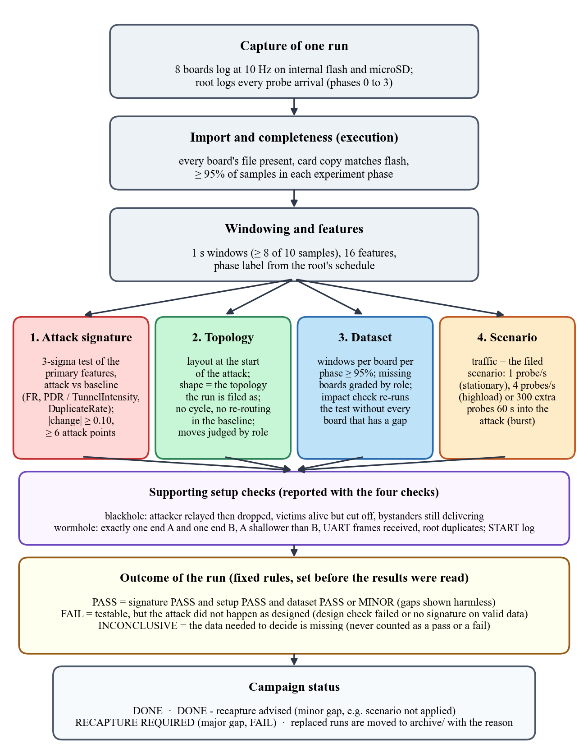
Figure 4.55 Order of the Checks That the Verifier Applies to Every Run
How to read it. Each box is one step, read from the top. A run is first imported and cut into one-second windows. The four checks in the middle row are then applied to the same windows, and the setup check below them confirms the roles of the boards. The results are combined by the rules in the yellow box, which were fixed before any result was read, and the campaign status at the bottom decides whether the run is kept or captured again.

4.2.7.7.1. Attack Signature
The attack signature check applies the 3-sigma test of Section 4.2.7.1 to the primary features of each attack. For the blackhole, the primary features are the ForwardingRatio of the attacker and the PDR of the victims. For the wormhole, they are TunnelIntensity, which is counted by the tunnel ends, and DuplicateRate, which is measured at the root (D-21). The windows of the attack phase are compared with those of the normal phase, and every five one-second windows are pooled into one point (Table 4.10). A primary feature passes when its attack mean lies more than three baseline standard deviations from the baseline mean in the expected direction, when it changes by at least 0.10 in absolute terms, and when it has at least six attack points. When the baseline did not vary at all, the z-score is undefined, and any move in the expected direction is accepted. A run passes the check when at least one primary feature passes. The support features (ConsistencyScore, IngressEgressDelta and NeighbourForwardingRatio for the blackhole, and TunnelBytes for the wormhole) are reported but do not decide the verdict. TunnelLatency and LatencyHopRatio are measured and not scored, because their normal phase has no usable spread. Figure 4.56 shows the check on one blackhole run and on one wormhole run.
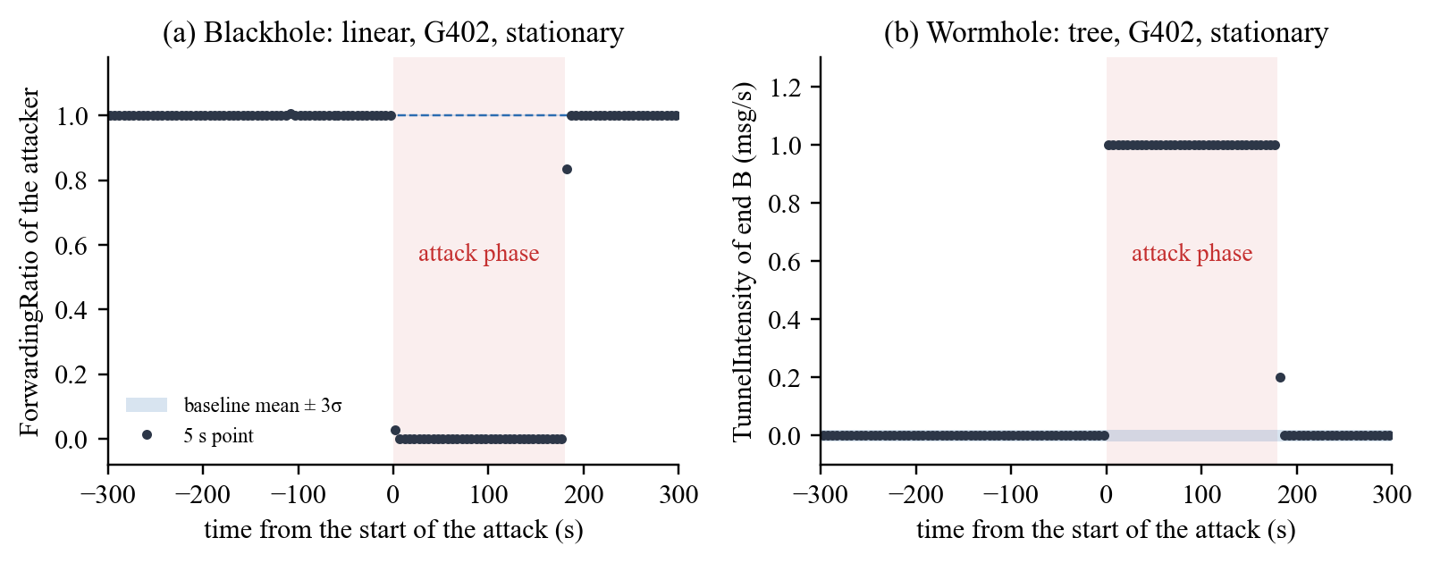
Figure 4.56 Attack Signature Check on Two Runs: (a) ForwardingRatio of the Blackhole Attacker, Linear Topology, G402, Stationary; (b) TunnelIntensity of Wormhole End B, Tree Topology, G402, Stationary
How to read it. The horizontal axis is the time in seconds from the start of the attack (negative values are the baseline), and the shaded area is the 180 s attack phase. Each dot is the mean of five one-second windows. The light blue band is the baseline mean plus or minus three baseline standard deviations (3σ); it is very thin here because the baseline barely varied. (a) The attacker forwarded every probe it received in the baseline (ratio 1.0, no unit) and none during the attack (0.0), so every attack point lies far outside the band. (b) The tunnel end sent nothing through the tunnel in the baseline (0 messages per second) and one message per second during the attack.

4.2.7.7.2. Topology
The topology check rebuilds the tree of the mesh at the start of the attack from the parent address that every board logs, and it compares the shape of that tree with the topology under which the run is filed. A linear run must form a chain with one board on each layer. A star run must have every child under one hub that sits behind the root (D-16, D-28). A tree or a partial-mesh run must branch over several hops without a cycle. The check also reads the parent changes during the experiment. A board that re-routes during the baseline fails the topology gate (D-27). A board that changes parent during the attack is judged by its role: the move is tolerated when the board stays a victim or stays a bystander, and the run fails when the board switches between the two (D-23, D-31). For the partial mesh, the verifier also records whether any board was seen under a second parent, and it adds a note when the run formed a plain tree (D-29). Figure 4.57 shows the layouts that the verifier rebuilt for six runs.
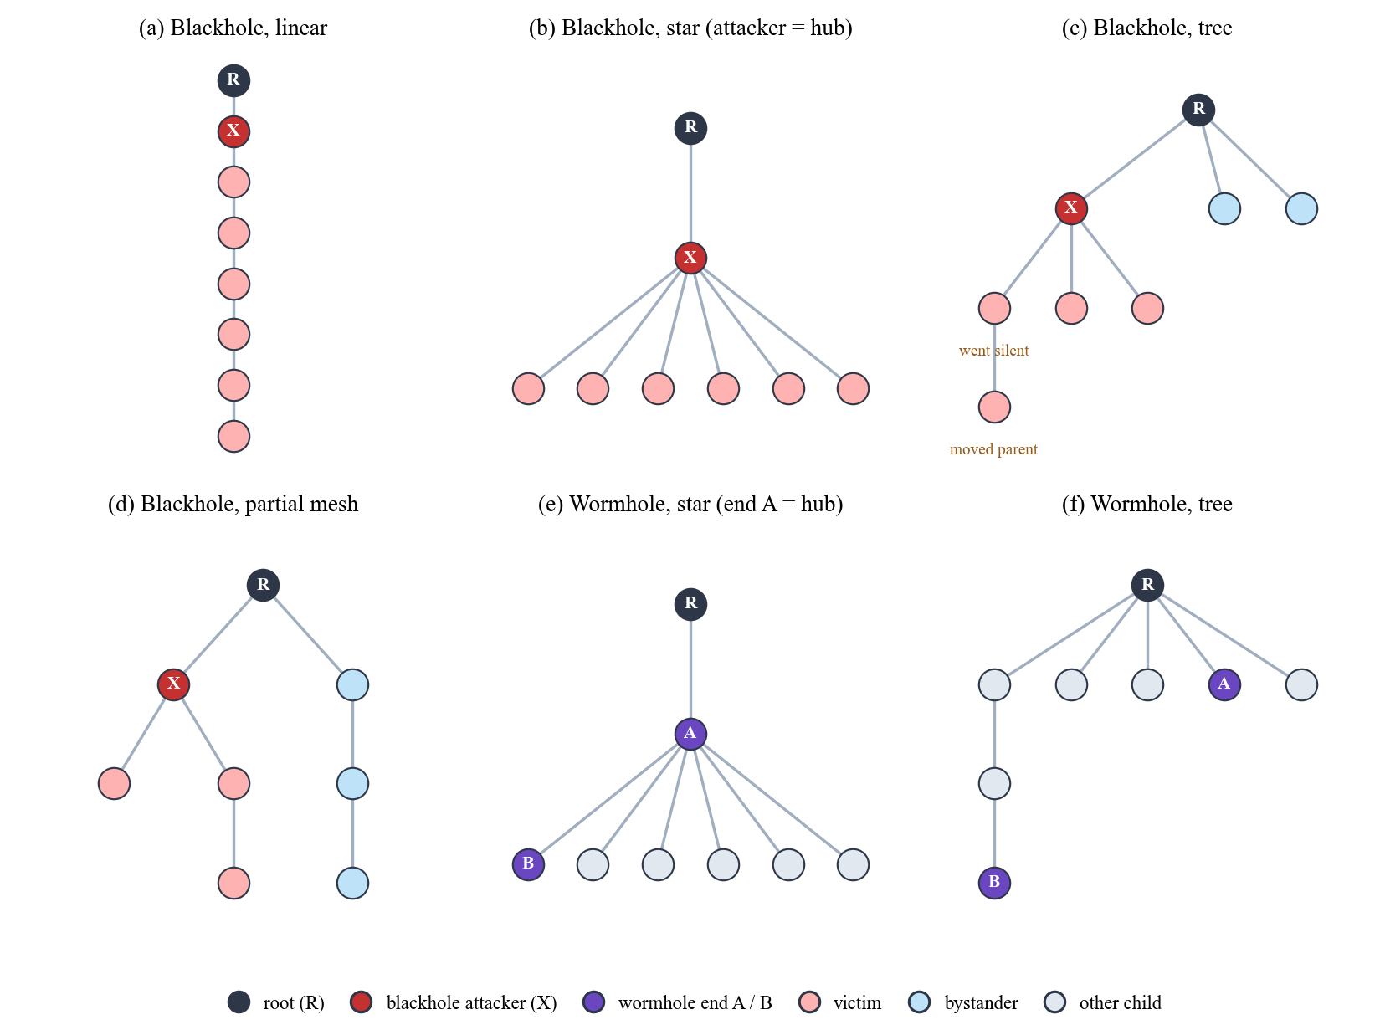
Figure 4.57 Layouts Rebuilt by the Topology Check at the Start of the Attack (Six Runs at G402)
How to read it. Each circle is a board, and each line joins a board to its parent, with the root (R) at the top. X is the blackhole attacker and A and B are the two ends of the wormhole. Red boards are victims, whose path to the root passes through the attacker, and blue boards are bystanders, whose path does not. Grey boards are the other children of a wormhole run, which are not tunnelled. Panels (a) to (d) and (f) are stationary runs and panel (e) is a highload run. In panel (c), one victim went silent 28 s into the attack and another moved to a new parent while it stayed a victim; the move was tolerated (D-23).

4.2.7.7.3. Dataset
The dataset check asks whether every board recorded enough of each phase for the result to be trusted. For each board, the number of one-second windows in the baseline (300 s), the attack (180 s) and the cooldown (120 s) is compared with the length of the phase, and a board below 95% in any phase is reported as a gap. A board that the root heard but whose file is missing is found from the arrival log of the root, and it is placed in the tree from the logged parent links and never from its delivery (D-32). Each gap is graded by the role of the board. A gap on the attacker or on a tunnel end is major. A gap on a victim or a bystander is minor while other boards of the same role still carry the evidence or the control. An impact check then repeats the attack signature test without every board that has a gap. When the result holds, the gaps are graded minor and are footnoted. When it does not hold, or when a major gap exists, the run cannot be validated and is captured again. Figure 4.58 shows a run with one minor gap.
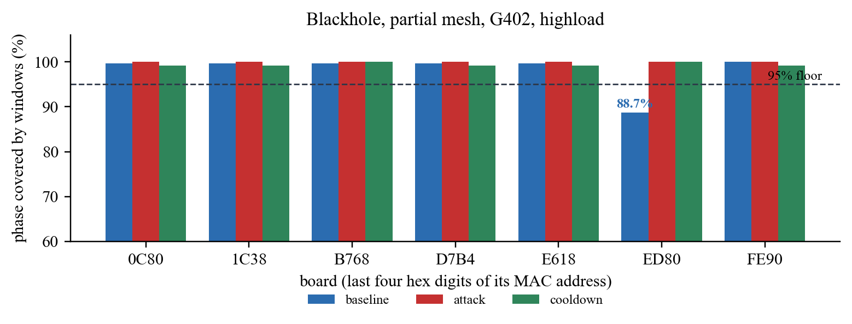
Figure 4.58 Dataset Check: Share of Each Phase Covered by Windows, per Board (Blackhole, Partial Mesh, G402, Highload)
How to read it. Each group of bars is one board, named by the last four hexadecimal digits of its MAC address, and each bar is the share (%) of a phase that the board covered with one-second windows. The dashed line is the 95% floor. Board ED80, a victim, covered only 266 of the 300 s of its baseline (88.7%), so the verifier reported a gap. The impact check repeated the attack test without ED80, the attack was still confirmed, and the run was kept with a minor gap.

4.2.7.7.4. Scenario
The scenario check confirms that the traffic of a run matched the scenario under which it is filed (Section 4.2.2.5). It reads the probe counters of the child boards. In a stationary run, each child sends about one probe per second for the whole run. In a highload run, each child sends about four probes per second, one every 250 ms. In a burst run, one child sends 300 extra probes within 10 s, about 60 s into the attack. A run whose scenario was not applied, for example a burst that fired outside the attack window, keeps its attack result, but it is graded as having a minor gap and a recapture is advised (D-34). The same check is applied to the benign runs, where the burst is expected in the part of the baseline that matches the attack window of an attack run. Figure 4.59 shows the three scenarios on three blackhole runs.
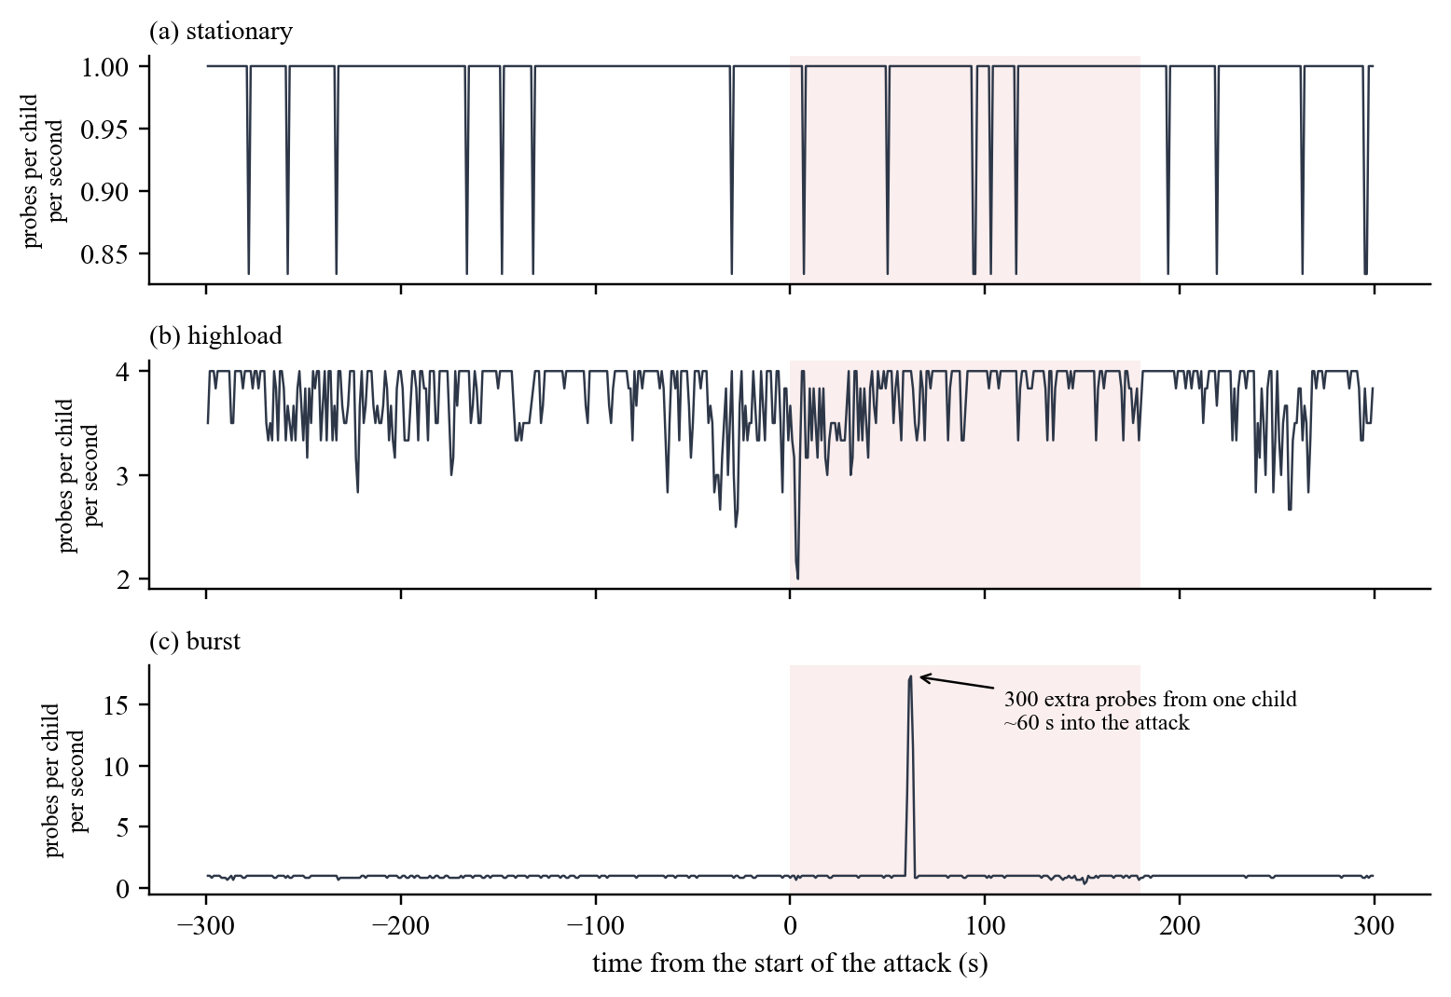
Figure 4.59 Scenario Check: Probes Sent per Child Board per Second in Three Runs (Blackhole, Star, G402)
How to read it. The horizontal axis is the time in seconds from the start of the attack, and the shaded area is the attack phase. The vertical axis is the mean number of probes that one child board sent in each second. (a) In the stationary run each child sent about one probe per second. (b) In the highload run each child sent about four probes per second; the short dips are seconds in which a board sent fewer probes. (c) In the burst run the line stays near one probe per second except for one spike about 60 s into the attack, when one child sent 297 extra probes within 10 s.

4.2.7.7.5. Outcome and Grade
The results of the checks are combined by fixed rules that were written into the verifier before the results were read (Table 4.26). A run is PASS when the attack signature passes, the setup check passes, and the data are complete or have only minor gaps. It is FAIL when the run could be tested but the attack did not happen as designed, and INCONCLUSIVE when the data needed to decide are missing. A missing piece of data is never counted as a pass or as a fail. Each run also receives a grade that states how complete its data are. Benign runs are checked the other way round: the same two signatures are tested on the cooldown of the benign run against its baseline, and a benign run is confirmed only when neither signature moves and the delivery stays healthy, with a PDR of at least 0.90 in both phases and every relay forwarding at least 90% of what it received. The outcomes of all 80 runs are reported in Section 6.2.6.
Table 4.26 Rules for the Outcome and the Grade of a Run

Result | Rule | What happens to the run
PASS (outcome) | Attack signature passes, setup check passes, and the data are complete or have only minor gaps | Kept in the labelled dataset
FAIL (outcome) | The run could be tested, but a design check failed (the attacker forwarded, no victim sat behind the attacker, a board switched between victim and bystander, the topology was wrong or the tunnel was reversed), or the signature did not move on valid data | Archived with the reason and captured again
INCONCLUSIVE (outcome) | The data needed for the decision are missing (attacker telemetry missing, too few victim-seconds, a major gap, or the role of a missing board cannot be placed) | Archived with the reason and captured again
STRONG or GOOD (grade) | Every board has usable data for the whole attack; STRONG when nothing needed a note, GOOD when a note was added (for example, a plain tree or a run with no run log) | Kept
MINOR GAPS (grade) | A gap on a victim, a bystander or the scenario that the impact check shows does not change the result | Kept; the gap is footnoted and a recapture is advised
MAJOR GAPS (grade) | A gap on data that the result depends on (the attacker, a tunnel end or the last control board) | Not validated; captured again

Legend:
● Outcome = the verdict of the verifier on the attack evidence of a run; grade = how complete the data of the run are.
● Design check = a check of the setup that the experiment depends on, such as the position of the attacker; impact check = the attack test repeated without the boards that have gaps.
● Victim = a board whose path to the root passes through the attacker; bystander = a board whose path does not; control = a bystander used to show that the loss is specific to the path of the attacker.
● Victim-seconds = seconds of the attack in which a victim had data; run log = the serial log of the root, saved by the capture tool.
Block B1. Paste this into Section 6.1 of the tab ‘latest version chapter 5 and 6’, in place of the paragraph that starts “[PENDING: the final dataset once all 80 runs are captured”.
Collection ended on 24 October 2026, and every run of the final plan was captured (Table 6.5). The 36 blackhole runs and the 36 wormhole runs cover each combination of topology, site and scenario once, and the 8 benign runs cover the linear and the star topologies at all three sites and the tree and the partial mesh at G402. Each run was analysed on its own and checked by the verifier (Section 4.2.7.7). The final captures hold 212,419 one-second windows in the blackhole runs, 207,025 in the wormhole runs and 37,464 in the benign runs, of which 171,251, 172,439 and 25,992 carry a phase label. The pooled tables of this chapter that are marked provisional still come from the 36 blackhole runs analysed on 20 October 2026, whereas Sections 6.2.2, 6.2.6 and 6.4.6 use the final captures.
Table 6.5 Runs of the Final Plan Captured and Verified, by Topology (final captures, 80 runs)

Topology | Blackhole runs (count) | Wormhole runs (count) | Benign runs (count) | Runs with outcome PASS (count) | Runs kept with a minor gap (count)
Linear | 9 | 9 | 3 | 21 | 1
Star | 9 | 9 | 3 | 21 | 0
Tree | 9 | 9 | 1 | 19 | 3
Partial mesh | 9 | 9 | 1 | 18 | 1
All | 36 | 36 | 8 | 79 | 5

Legend:
● Runs = captures of the final plan, one for each combination of attack, topology, site and scenario (benign runs: D-35).
● PASS = the verifier confirmed the attack (or, for a benign run, confirmed clean normal traffic); the one benign run that is not PASS is the partial mesh at G402 with highload, which is inconclusive because its arrival log was not exported (Section 6.2.6).
● Minor gap = a gap that the impact check showed does not change the result (Section 4.2.7.7.3).
Table 6.5 shows that the campaign reached its plan in full. Every topology has 18 attack runs, nine with each attack, and 79 of the 80 runs passed the verifier. The five runs kept with a minor gap are all blackhole runs: one on the linear topology, where the burst fired outside the attack window, three on the tree, where one board is missing or has a gap in its windows, and one on the partial mesh, where a victim covered 88.7% of its baseline. The benign runs are spread unevenly, with three on the linear topology and the star but only one each on the tree and the partial mesh, which Section 6.5.4 lists as a limit.
Block B2. Paste this into Section 6.2.2 (Wormhole: Tunnel Replay) of the latest tab, in place of its [PENDING …] paragraph.
Every wormhole run was checked with the two primary features of D-21. TunnelIntensity is the number of messages per second that the tunnel ends sent through the tunnel, and DuplicateRate is the share of the attack windows of Node B in which the root received a second copy of the same probe. Both features moved in all 36 runs (Table 6.8). In 35 runs the normal phase never varied, because the tunnel was silent and the root saw no duplicate in the baseline and the cooldown, so the z-score is undefined and any move in the expected direction counts. In the remaining run, star at G402 with highload, TunnelIntensity rose from 0.001 to 4.000 messages per second, which is 261 baseline standard deviations. During the attack, the tunnel carried about one message per second in the stationary and burst runs and about four per second in the highload runs, which matches the probe rate of Node B.
The setup check passed in every wormhole run. Exactly one Node A and one Node B were present, their roles did not change during the experiment, Node A sat shallower than Node B, and Node A received 99% to 101% of the tunnel frames that Node B reported sending (values above 100% arise because the two boards report their counters at slightly different times). In the 30 runs that have a run log of the root, none was started with START_ANYWAY, and the other six runs have no run log, so this could not be checked for them.
The tunnel skipped at least one hop in every run (Figure 6.4). In the linear topology, where every board sits on its own layer, it skipped two to five hops. In the star, which is built one hop down with Node A as the hub (D-28), it skipped exactly one hop, and in the tree and the partial mesh it skipped one or two hops. The two copies of a probe of Node B reached the root a median of 5 ms apart in the star and the tree, 8 ms apart in the linear topology and 33 ms apart in the partial mesh. One tree run at G402 had a median gap of 301 ms, which is the only value above 70 ms. TunnelLatency is reported and not scored (D-21), because it exists only while the tunnel runs and so has no normal value to test against.
The boards outside the tunnel were not affected. Their PDR was 0.9999 in the baseline and in the attack, and they recorded no parent change and no hop change in any window (Section 6.2.4). A wormhole run therefore has no victims, and the attack is visible only on Node B, on Node A and at the root (D-17).
Table 6.8 Wormhole Runs by Topology: Setup and Tunnel Evidence (final captures, 36 wormhole runs)

Topology | Runs confirmed (count) | Depth of end A (hops) | Depth of end B (hops) | Hops skipped by the tunnel (hops) | Attack windows of B with a duplicate at the root (count, of about 180) | Tunnel frames received by A (% of frames sent by B) | TunnelLatency, median per run: median (range) (ms)
Linear | 9 of 9 | 1 to 4 | 4 to 7 | 2 to 5 | 179 to 180 | 99 to 101 | 8.3 (3.6 to 29.7)
Star | 9 of 9 | 1 | 2 | 1 | 178 to 180 | 99 to 101 | 5.0 (4.2 to 12.4)
Tree | 9 of 9 | 1 to 2 | 3 to 4 | 1 to 2 | 179 to 180 | 100 to 101 | 5.0 (3.2 to 300.6)
Partial mesh | 9 of 9 | 1 to 3 | 2 to 4 | 1 to 2 | 179 to 180 | 99 to 101 | 32.9 (4.9 to 69.9)
All | 36 of 36 | 1 to 4 | 2 to 7 | 1 to 5 | 178 to 180 | 99 to 101 | 6.0 (3.2 to 300.6)

Legend:
● Node A = the exit end of the tunnel, on the root side; Node B = the entry end, deeper in the mesh; depth = hops from the root at the start of the attack.
● Hops skipped = depth of B minus depth of A, the number of hops that the tunnelled copy of a probe of B avoids.
● Duplicate = a second copy of the same probe (same sender and sequence number) received by the root; the attack phase lasts 180 s, so a run has about 180 attack windows of B.
● Tunnel frames = the frames written to the wired UART link; TunnelLatency = the gap between the arrival times of the two copies of one probe at the root (D-3).
● Confirmed = both primary features passed and the setup check passed (Section 4.2.7.7).
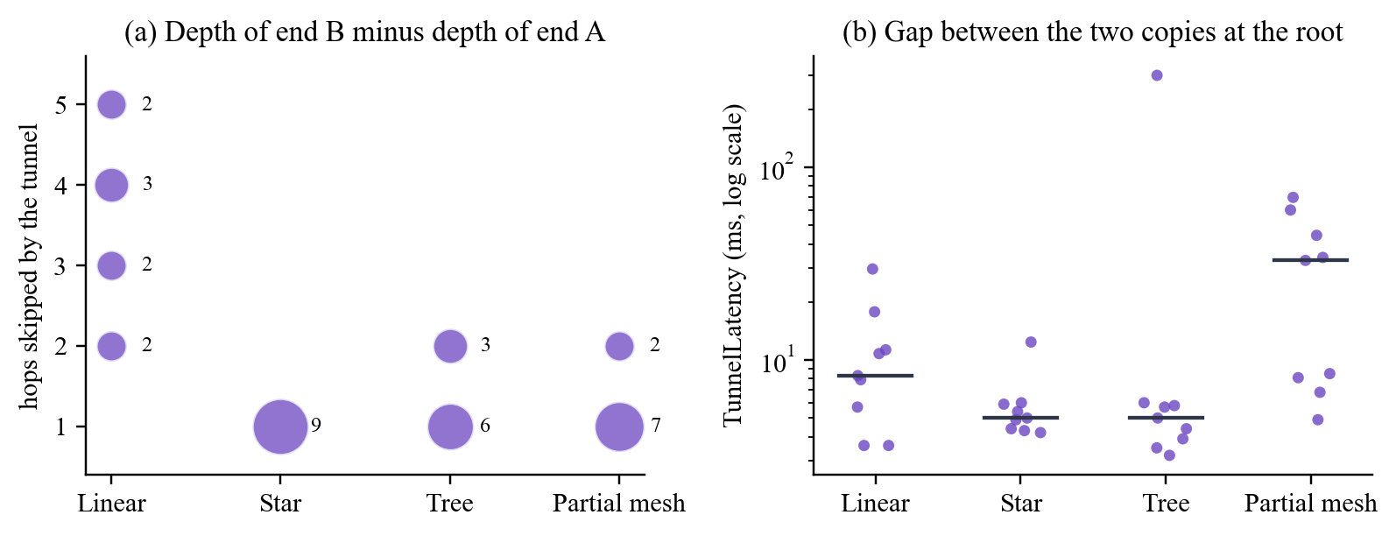
Figure 6.4 Hops Skipped by the Tunnel and Gap between the Two Copies of a Probe, by Topology (final captures, 36 wormhole runs)
How to read it. (a) Each bubble is a number of hops skipped (depth of end B minus depth of end A), and its size and the number next to it give how many runs had that value. (b) Each dot is one run, and its height is the median gap, in milliseconds on a logarithmic scale, between the two arrivals of the same probe at the root; the black line is the median over the nine runs of the topology.
Block B3. Paste this into Section 6.2.4 of the latest tab, in place of “[PENDING: the predictions tested for the wormhole (Table 3.5), once the wormhole runs are analysed.]”.
Table 3.5 predicted that the wormhole would distort the topology, so that parent switches and hop changes would rise and the relationship between RSSI and hop would weaken. This was not observed. In the 36 wormhole runs, the boards outside the tunnel had a ParentSwitchRate and a HopChangeCount of 0 in every window of both phases, their RSSI_Hop_Diff moved from 2.67 dB to 2.72 dB (Cohen’s d = 0.02) and their RSSI_mean from −69.2 dBm to −69.1 dBm (d = 0.00). The tunnel ends behaved in the same way, with the RSSI_Hop_Diff of Node B moving from 5.54 dB to 5.68 dB (d = 0.02). The tunnel is a wire outside the mesh, and the routing of the mesh never adopts it (D-20), so no board has a reason to change its parent. An application-layer replay tunnel therefore reproduces the duplicate-delivery signature of a wormhole without its topological signature. The RetryRate of Node B rose from 0 to about 0.50 during the attack, but this is not a radio retransmission: on Node B the counter holds the frames written into the tunnel (D-15), so it records the tunnel and not the link layer.
Block B4. Paste this as a new subsection after Section 6.2.5 of the latest tab, before the heading 6.3 EDA Results (use the same heading style as 6.2.5).

6.2.6. Verification of Every Run
Section 4.2.7.7 sets out the four checks that the verifier applies to every run. They were applied again to the final captures on 24 October 2026, and Table 6.10 gives the result of each check for the three kinds of run. All 72 attack runs had the outcome PASS. The attack signature and the setup check passed in every attack run. The topology check passed without a note in 53 runs; the 18 partial-mesh runs carry the note that they formed plain trees (D-29), and the tree blackhole run at G402 with stationary traffic carries the note that board ED80 moved to a new parent while it stayed a victim (D-23). The dataset check found complete data in 67 attack runs and minor gaps in 5, and in each of the five the impact check showed that the gap does not change the result. The scenario check found the scenario applied in 71 attack runs. In the remaining run, blackhole on the linear topology at G402 with burst traffic, the burst was fired outside the attack window, so the run keeps its attack result and is graded as having a minor gap (D-34). Figure 6.6 shows the same results run by run.
The 8 benign runs were checked the other way round (Section 4.2.7.7.5). Seven were confirmed as clean normal traffic: neither attack signature moved between the baseline and the cooldown, every relay forwarded at least 90% of what it received, and the PDR of the child boards was between 0.999 and 1.000 in both phases. The eighth, partial mesh at G402 with highload, is inconclusive, because the arrival log of its root was not exported when the run ended, so its PDR cannot be computed. The file is still on the memory card of the root and can be imported. The scenario was applied in every benign run.
Table 6.10 Result of Each Check, by Kind of Run (final captures, 80 runs)

Check and result | Blackhole runs (count, of 36) | Wormhole runs (count, of 36) | Benign runs (count, of 8)
Attack signature: moved (attack runs) or did not move (benign runs) | 36 | 36 | 7
Attack signature: could not be tested | 0 | 0 | 1
Topology: as filed, no note | 26 | 27 | not checked
Topology: as filed, with a note (plain tree or tolerated move) | 10 | 9 | not checked
Dataset: complete | 31 | 36 | 7
Dataset: minor gaps, result unchanged | 5 | 0 | 0
Dataset: arrival log of the root missing | 0 | 0 | 1
Scenario: applied | 35 | 36 | 8
Scenario: not applied | 1 | 0 | 0
Setup (roles of the boards): passed | 36 | 36 | not checked
Outcome: PASS | 36 | 36 | 7
Outcome: INCONCLUSIVE | 0 | 0 | 1
Grade: STRONG / GOOD / MINOR GAPS | 4 / 27 / 5 | 21 / 15 / 0 | 7 / 0 / 0

Legend:
● The checks are defined in Section 4.2.7.7; count = number of runs.
● For a benign run, the attack signature check passes when neither signature moves between the baseline and the cooldown; a benign run has no attacker, so its topology and setup are not checked against an attack design.
● Note = the run is kept as it is, and the note is reported; plain tree = no board was seen under a second parent (D-29); tolerated move = a board changed parent but kept its role (D-23).
● Grade: STRONG = complete data and nothing to note; GOOD = complete data with a note; MINOR GAPS = a gap that does not change the result.
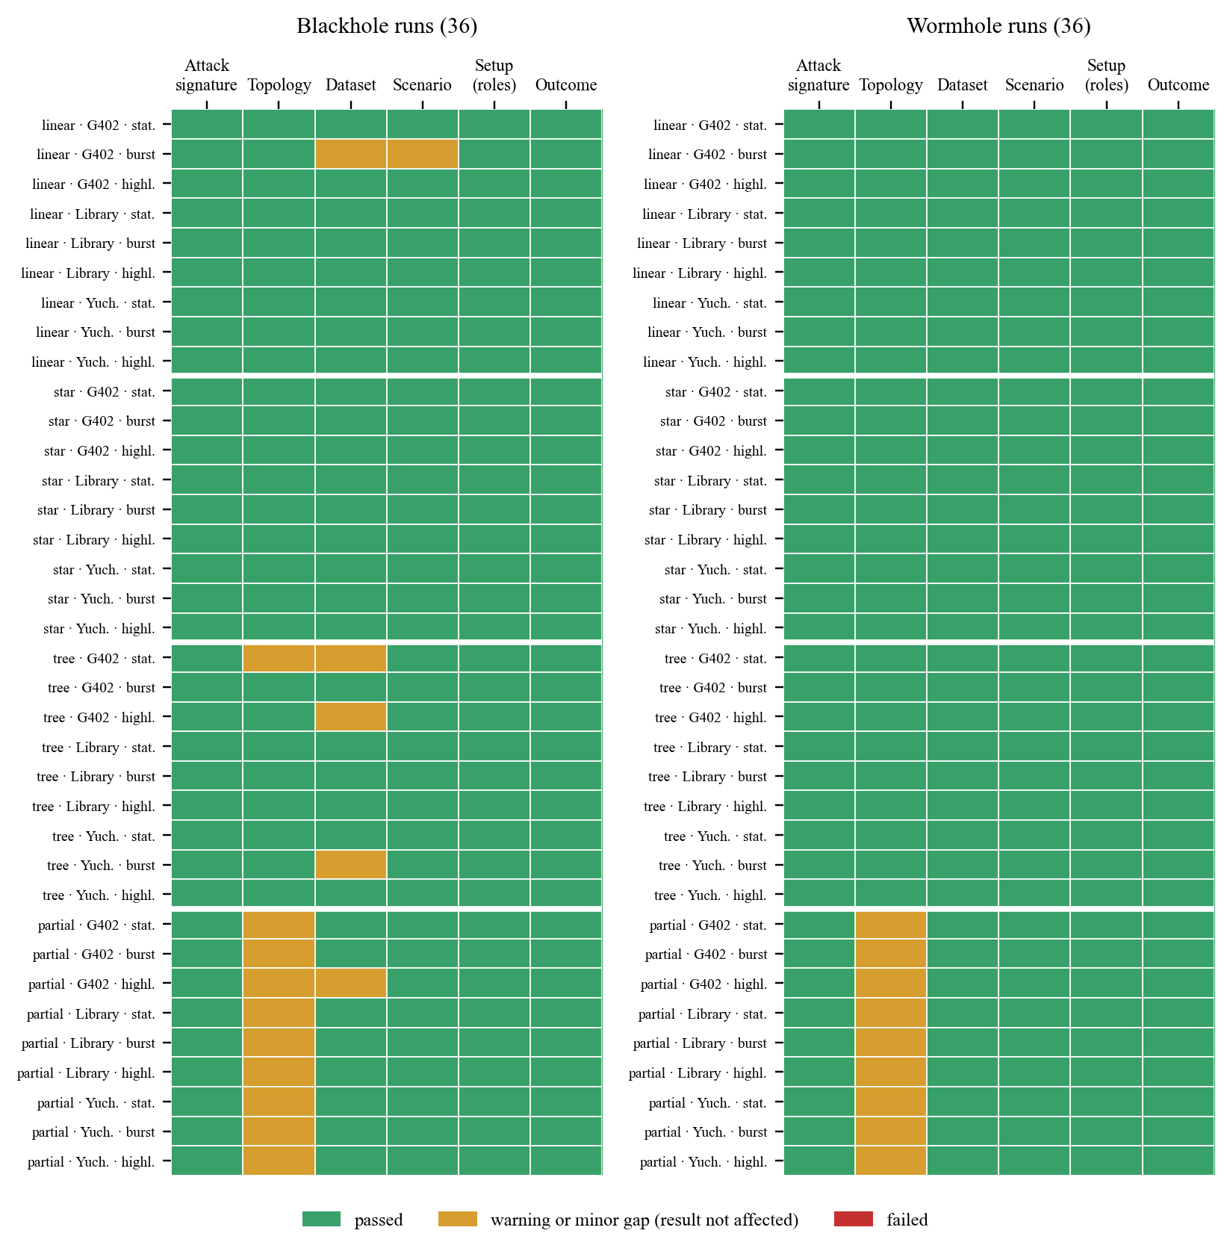
Figure 6.6 Result of Each Check for Each of the 72 Attack Runs (final captures)
How to read it. Each row is one run, named by its topology, site and scenario, and each column is one check, with the outcome in the last column. Green means passed, amber means a warning or a minor gap that does not change the result, and red means failed. The white lines separate the four topologies. The amber column in the partial-mesh rows is the plain-tree note of D-29. No cell is red.
A capture was accepted into the dataset only when it passed these checks. The captures that did not pass were archived with the reason and captured again, and they are kept outside the labelled dataset (Table 6.11). They are reported here because they show how a real ESP-WIFI-MESH network behaves, and this behaviour matters for anyone who uses a verifier of this kind. Two patterns recur. First, instability of the mesh can mimic an attack. In a benign highload run on the linear topology, made at home during testing, the PDR fell from 0.998 in the baseline to about 0.72 in the cooldown with no attacker present, and two relays forwarded only 83% and 85% of what they received, so the blackhole signature passed on normal traffic, and the run was rejected as a reference for normal behaviour. Second, instability of the attacking boards can hide an attack or break its setup. In one blackhole capture no board sat behind the attacker, so there was no one to cut off. In another, a board switched between victim and bystander during the attack. In a wormhole capture, only one tunnel end logged its role, and the root received no duplicates. In a fourth, a tunnel end restarted during the attack and its counters made the tunnel look lossy. Missing or unreadable data on a single board made several other captures inconclusive. None of these captures is used as attack or normal training data.
Table 6.11 Captures Replaced or Kept outside the Dataset, with the Outcome and Cause Found by the Verifier

Capture (attack, topology, site, scenario, date) | Outcome | Cause found by the verifier | What was done
Blackhole, star, G402, stationary (1 Oct) | INCONCLUSIVE | A missing board could not be placed in the tree, so its role was undetermined | Captured again
Blackhole, tree, G402, stationary (18 Oct, first) | INCONCLUSIVE (major gap) | The phase labels of victim B768 were out of step with the rest of the run | Captured again
Blackhole, tree, G402, stationary (18 Oct, second) | INCONCLUSIVE (major gap) | The attacker (1C38) has windows for only 106 of the 178 s of its attack (59%) | Captured again
Blackhole, linear, Yuchengco, stationary (19 Oct) | PASS with a minor gap | One board was below the 95% coverage floor, and a recapture was advised | Captured again
Blackhole, tree, G402, burst (19 Oct) | INCONCLUSIVE (major gap) | The phase labels of board FE90 could not be used | Captured again
Blackhole, tree, G402, highload (19 Oct, first) | FAIL (setup) | Board B768 changed parent during the attack and moved between the victim class (94 s) and the bystander class (D-23) | Captured again
Blackhole, tree, G402, highload (19 Oct, second) | INCONCLUSIVE (major gap) | The phase labels of board D7B4 could not be used | Captured again
Blackhole, tree, G402, highload (19 Oct, third) | FAIL (setup) | No board sat behind the attacker, so there was no victim to cut off | Captured again
Wormhole, tree, DLSU Library, stationary (16 Oct) | INCONCLUSIVE | End A went silent for about 36 s during the attack and its counters restarted, which made the tunnel look lossy (18% of frames missing) | Captured again
Wormhole, star, G402, highload (20 and 21 Oct) | Not analysed | The hub board (end A) browned out and dropped during the attack, which cut every child off | Captured again
Wormhole, partial mesh, G402, stationary (21 Oct) | PASS with a minor gap | A recapture was advised | Captured again
Wormhole, partial mesh, G402, highload (21 Oct) | PASS with a minor gap | A recapture was advised | Captured again
Wormhole, tree, G402, stationary (22 Oct) | FAIL (setup) | Only one board logged a tunnel role (end A), and the root logged no duplicate arrivals during the attack | Captured again
Wormhole, tree, G402, highload (23 Oct) | PASS with a minor gap | The highload scenario was not applied (D-34) | Captured again
Wormhole, tree, Yuchengco, burst (24 Oct) | PASS with a minor gap | The burst was not applied in the attack (D-34) | Captured again
Benign, partial mesh, G402, highload (23 Oct, first) | INCONCLUSIVE | Too little data to test it as a normal reference | Captured again
Benign, linear, home, highload (testing) | FAIL | The blackhole signature passed on normal traffic: the PDR fell from 0.998 in the baseline to about 0.72 in the cooldown with no attacker, and two relays forwarded only 83% and 85% | Kept outside the plan (home is not a campaign site, D-19)
Blackhole, linear, home, highload (testing) | FAIL | The two victims behind the attacker still delivered 83% during the attack, so they were not cut off | Kept outside the plan (D-19)

Legend:
● Outcome and grade are defined in Table 4.26; FAIL (setup) = a design check failed; major gap = a gap on data that the result depends on.
● Phase labels out of step = the phase marks of a board did not line up with the schedule of the root, so its windows could not be assigned to baseline, attack or cooldown.
● Brownout = a drop of the supply voltage that resets a board; tunnel frames = frames written to the wired link between the two wormhole ends.
● Board names such as B768 are the last four hexadecimal digits of the MAC address; dates are in October 2026.
● Captured again = the run was repeated and the replaced capture was moved to the archive folder with its reason; it is not part of the labelled dataset.
Block C1. Paste this as a new subsection after Section 6.4.5 (Projections) of the latest tab, in place of the paragraph that starts “[PENDING: the final clustering for the pooled 80 runs” (use the same heading style as 6.4.5).

6.4.6. Clustering of the Final Dataset
Sections 6.4.1 to 6.4.5 cluster the windows of the 36 blackhole runs of the 20 October snapshot. After collection ended, the same procedure was applied to the final dataset of 80 runs, with three labels instead of two: normal (the baseline and the cooldown of every run, together with every window of the benign runs), blackhole (the attack phase of a blackhole run) and wormhole (the attack phase of a wormhole run). As before, the labels were used only after the clusters had been formed. The pool holds 254,336 windows of non-attacker nodes that have every FULL feature: 183,910 normal, 38,232 blackhole and 32,194 wormhole windows, so the majority rate is 0.723. The best possible ARI is 0.335. It is the agreement reached by a partition that puts exactly the windows in which an attack was felt (the attack windows of the blackhole victims) in one group and every other window in the other, and it is low because the bystanders of the blackhole and every board of a wormhole run carry the attack label but behave as normal nodes.
The two filters of Section 4.2.4.6 were applied to this pool first. The low-variance filter removed ParentSwitchRate (100% identical values), HopChangeCount (100%), HopStabilityDuration (99.9%) and RSSI_stability (98.2%), as before, but it now also removed PDR, because 91.4% of the windows have a PDR of exactly 1.000 once the wormhole and benign runs are added; neither kind of run loses probes. The correlation filter removed nothing, because the largest |r| among the remaining features is 0.08. Applied as written, the filters therefore leave only RSSI_mean, RSSI_var and RSSI_Hop_Diff. The filter rule was fixed before any wormhole run existed, and PDR is the only feature that carried the blackhole in Section 6.4.2, so the four-feature set of Section 6.4.1 (PDR with the three RSSI features) was clustered as well. Both sets are reported in Table 6.17, together with the FULL set.
Table 6.17 Clustering of the Final Dataset with Three Labels, Means over Seeds 42, 7 and 123 (final captures, 80 runs)

Feature set | Algorithm | Silhouette (−1 to 1) | Davies–Bouldin (0 and up) | Purity (0 to 1) | ARI, three labels (−1 to 1) | ARI, windows in which the blackhole was felt (−1 to 1)
PDR + RSSI (4 features) | K-Means | 0.579 | 0.668 | 0.803 | 0.322 | 0.994
PDR + RSSI (4 features) | Ward | 0.575 | 0.650 | 0.802 | 0.318 | 0.987
PDR + RSSI (4 features) | GMM | 0.569 | 0.980 | 0.790 | 0.299 | 0.887
PDR + RSSI (4 features) | DBSCAN (14 clusters, 2.7% noise) | 0.442 | 0.415 | 0.798 | 0.286 | 0.771
PDR + RSSI (4 features) | Spectral | 0.193 | 1.847 | 0.748 | 0.109 | 0.313
REDUCED by the filters (3 features, no PDR) | K-Means | 0.320 | 1.249 | 0.727 | 0.001 | −0.008
REDUCED by the filters (3 features, no PDR) | Ward | 0.307 | 1.387 | 0.727 | 0.002 | −0.003
REDUCED by the filters (3 features, no PDR) | GMM | 0.398 | 2.083 | 0.727 | −0.026 | −0.015
REDUCED by the filters (3 features, no PDR) | DBSCAN (11 clusters, 1.3% noise) | 0.493 | 0.459 | 0.727 | −0.005 | −0.007
REDUCED by the filters (3 features, no PDR) | Spectral | 0.034 | 1.130 | 0.727 | 0.001 | −0.004
FULL (8 features) | K-Means | 0.840 | 0.770 | 0.721 | −0.005 | −0.006
FULL (8 features) | Ward | 0.837 | 0.789 | 0.721 | −0.005 | −0.009
FULL (8 features) | GMM | 0.617 | 1.497 | 0.755 | 0.177 | 0.492
FULL (8 features) | DBSCAN (6 clusters, 2.7% noise) | 0.529 | 0.438 | 0.800 | 0.292 | 0.801
FULL (8 features) | Spectral | −0.072 | 2.028 | 0.721 | 0.000 | −0.010

Legend:
● Three labels = normal (baseline, cooldown and benign runs), blackhole (attack phase of a blackhole run) and wormhole (attack phase of a wormhole run); they are used only after clustering.
● PDR + RSSI = PDR, RSSI_mean, RSSI_var and RSSI_Hop_Diff (the REDUCED set of Section 6.4.1); REDUCED by the filters = RSSI_mean, RSSI_var and RSSI_Hop_Diff; FULL = the 8 features of Table 6.13.
● Values are means over the three seeds with k = 2, except DBSCAN, which chooses its own number of clusters (mean number and share of windows left as noise in brackets).
● Windows in which the blackhole was felt = the attack windows of the blackhole victims; this column shows whether a method finds the attack where it actually acted.
● Silhouette, Davies–Bouldin, purity and ARI are defined under Table 6.14; the majority rate of this pool is 0.723, and the best possible ARI with three labels is 0.335.
With PDR among the features, K-Means with k = 2 reached an ARI of 0.322 against the three labels, close to the best possible 0.335, and 0.994 against the windows in which the blackhole was felt. Ward (0.318), GMM (0.299) and DBSCAN (0.286) agree, and spectral clustering is again the weakest method (0.109). Figure 6.16 shows what the clusters contain. One cluster of 511 windows (seed 42) is 99.4% attack windows of blackhole victims, with a mean PDR of 0.000. The other cluster holds everything else, namely the normal windows, the attack windows of the blackhole bystanders, the benign runs and every attack window of the wormhole runs, all with a mean PDR of 1.000. The wormhole windows were not separated at all: their agreement with the clusters, taken against all other windows, is an ARI of −0.084, and adding clusters did not help, because at k = 3 the extra cluster only split the normal-looking windows into two groups with the same mixture of kinds. Without PDR, that is, with the set that the filters leave, no algorithm agreed with the labels for any k from 2 to 8 (ARI between −0.031 and 0.008), and purity stayed at the majority rate of 0.727. On the FULL set, K-Means and Ward again cut off a small group of windows with an extreme RSSI variance (ARI −0.005), whereas DBSCAN and GMM, which can follow the PDR dimension, reached 0.292 and 0.177.
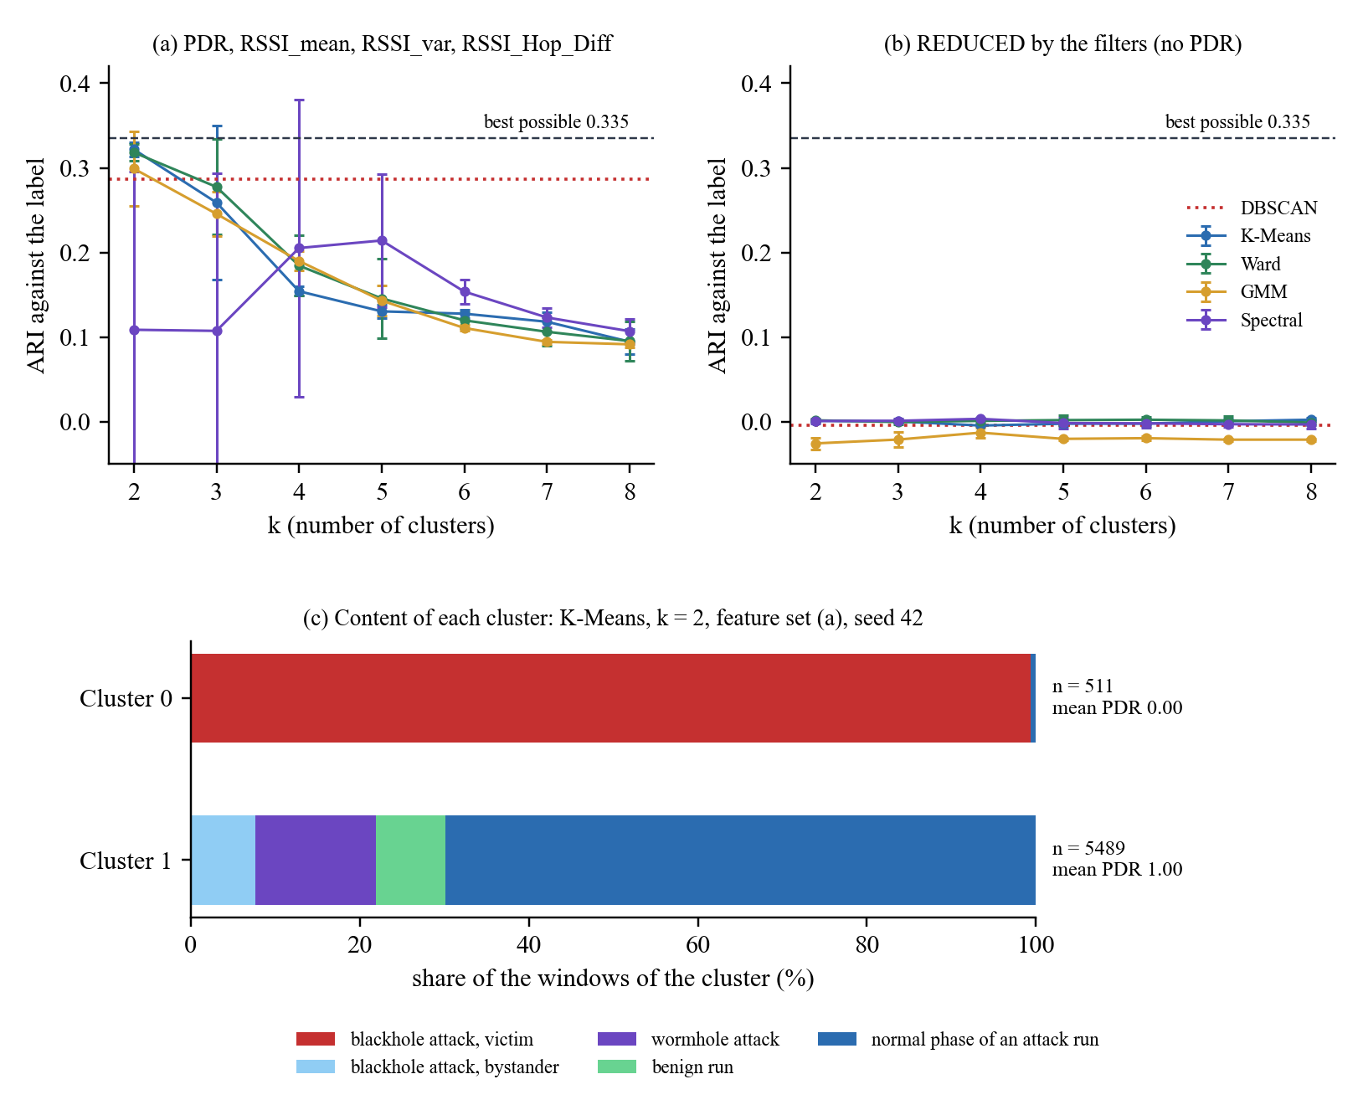
Figure 6.16 Clustering of the Final Dataset with Three Labels (final captures, 80 runs)
How to read it. (a) and (b) The horizontal axis is k, the number of clusters, and the vertical axis is the ARI against the three labels (1 = exact match, 0 = no better than chance). Each coloured line is one algorithm, with bars of ±1 standard deviation over the three seeds; the dotted line is DBSCAN, and the dashed line is the best possible value, 0.335. Panel (a) uses PDR with the three RSSI features, and panel (b) uses the three RSSI features that the filters leave. (c) Each bar is one K-Means cluster at k = 2, divided into the share (%) of five kinds of window, with its number of windows (n) and its mean PDR on the right. Cluster 0 is almost entirely red (attack windows of blackhole victims), and the wormhole windows (purple) lie in Cluster 1 together with the normal windows.
The final dataset therefore confirms the blackhole result of Sections 6.4.2 to 6.4.4 and adds a clear negative result for the wormhole. Seen from the boards outside the tunnel, a wormhole run looks exactly like normal traffic, because the tunnel neither drops nor reroutes their probes (Section 6.2.4). The wormhole is visible only in the tunnel counters of its two ends and in the duplicates that the root receives (Section 6.2.2). These are records of the attack itself, and the leakage audit keeps them out of the model inputs in the same way as the forwarding ratio of the blackhole attacker (Table 6.9). A wormhole that is emulated at the application layer is therefore not separable by unsupervised clustering of the cross-layer features of the honest nodes, and the benign runs fall in the same cluster as the normal phases of the attack runs, which is the expected behaviour of a stand-alone control.
Block C2. Section 6.5 of the latest tab: replace the paragraph “[PENDING: this discussion reads the blackhole results only …]” with the next paragraph, and add the paragraph after it at the end of Section 6.5.1 (after the paragraph on the third objective).
[PENDING: the discussion covers the blackhole, the wormhole and the benign runs. Read every sentence again against the final tables once the pooled tables of Sections 6.1 to 6.4.5 have been rerun on the 80 runs.]
The final dataset extends these answers to the wormhole. For the first objective, the 36 wormhole cells were run on the same testbed, and in every run the tunnel copied the probes of Node B to the root over a path one to five hops shorter than the normal path (Table 6.8). For the second objective, the dataset grew to 80 runs and 456,908 one-second windows, of which 369,682 carry a phase label, and every run was verified before it was accepted (Section 6.2.6). For the third objective, the wormhole windows did not separate from the normal windows in any feature set (Section 6.4.6), because the tunnel leaves the delivery, the radio links and the topology of the honest nodes as they were. The study therefore finds that, on ESP-WIFI-MESH, an application-layer blackhole is separable through the delivery ratio alone, whereas an application-layer wormhole is not separable through the cross-layer features of the honest nodes.
Block C3. Section 6.5.2 of the latest tab: replace the paragraph that starts “[PENDING: the comparison for the wormhole with Zhukabayeva et al. [71]” with the next paragraph.
For the wormhole, Ramírez Gómez et al. [72] propose duplicated packets as the signature by which a wormhole can be detected in a ZigBee network. The tunnel of this study produced exactly that signature: in every wormhole run, the root received a second copy of the probe of Node B in 178 to 180 of the attack windows, and none in the normal phases (Table 6.8). Zhukabayeva et al. [71] report that a wormhole shortened a route from four hops to three and raised the average delay by about 40%. In this study the tunnel offered a path one to five hops shorter than the normal path of Node B, but the routing of the mesh never adopted it (D-20), so no route changed and the delay of the normal copy stayed as it was; the two copies reached the root a median of 5 to 33 ms apart, depending on the topology. The difference comes from the design: in [71] the attack acts inside the routing protocol, whereas here the tunnel copies probes outside the mesh. [PENDING: update Table 4.23 from the final results. Table 4.23 and Section 4.2.7.6 say that Khan et al. [22] report delivery above 97%; their campus result excludes node H, so add that exception.]
Block C4. Section 6.5.3 of the latest tab: add this paragraph at the end of the section.
The same holds for the wormhole. The tunnel copies the probes of Node B over a wire, and Node A injects each copy near the root, but no board ever routes through the tunnel, so the honest nodes see no change in delivery, signal or parent (Section 6.2.4). The dataset therefore records the duplicate-delivery signature of a wormhole and not its false-neighbour effect, in which distant nodes appear to be neighbours and the routing adopts the shortcut. This is why the wormhole is invisible to the clustering of the honest nodes (Section 6.4.6), and, as for the blackhole, it is a property of the emulation as much as of the attack.
Block C5. Section 6.5.4 (Limits) of the latest tab: replace the paragraph “The partial-mesh runs behave as plain trees. …” with the first paragraph below, and add the second and third at the end of the section. (The paragraph on normal and benign runs was already updated directly in the latest tab.)
The partial-mesh runs behave as plain trees. In all 18 partial-mesh runs (9 blackhole and 9 wormhole), every node was seen under a single parent during the labelled phases, and parent changes occurred only during mesh formation, so these runs behave as plain trees (Section 1.4.1).
A verifier that compares phases within one run can be misled by the network itself, and the captures that were replaced during the campaign show both directions of error (Table 6.11). A mesh that degrades on its own can look like a blackhole: a benign highload run made at home passed the blackhole signature with no attacker present. An attacking board that browns out or restarts can hide the attack or break its setup, as in the wormhole captures in which a tunnel end went silent or only one end logged its role. These cases are the reason why the outcome of a run never rests on a threshold alone and why the setup and dataset checks are part of the verdict. They also show that a dataset made on real hardware has to report its failed captures and not only its successful ones.
Both attacks were emulated at the application layer, so their effect on the honest nodes is limited by construction: the blackhole removes delivery and nothing else, and the wormhole changes nothing on the honest nodes. The dataset cannot show how an attack that is adopted by the routing of the mesh would change their cross-layer features (Sections 6.5.3 and 6.6).
Block C6. Section 6.6 (Future Work) of the latest tab: add these paragraphs after the existing paragraph.
The benign control could be completed with the four benign runs that were dropped from the plan, namely the tree and the partial mesh at the DLSU Library and at Yuchengco, so that every topology has a benign run at every site and the confounding of site and scenario within a topology is removed. Repeating each cell, instead of running it once, would separate the differences between sites from the noise between runs (Section 6.5.4).
A supervised model could be trained on the labelled windows as a next step. The single-feature audit (Section 6.2.3) and the final clustering (Section 6.4.6) show, however, that such a model would mostly learn the delivery ratio for the blackhole and would find nothing for the wormhole among the features of the honest nodes. A fair test would therefore keep the records of the attackers themselves out of the inputs and would need attacks that act below the application layer, so that the other cross-layer features have something to detect.
The passive sniffer gave MAC-layer retransmission counts for the blackhole runs only, because the wormhole runs could not be aligned with the clock of the sniffer (D-15). Aligning the sniffer with the root, for example through a shared start signal, would add MAC-layer evidence to the wormhole data.
Block C7. Section 6.7 (Conclusion) of the latest tab: replace the paragraph that starts “[PENDING: state the contribution of the study” with the paragraphs below.
This study set out to build a cross-layer dataset from a real ESP32-based ESP-WIFI-MESH network and to find out whether normal and attack-induced behaviour can be told apart without labels. An eight-board testbed was built and run at three sites on the DLSU campus, in four topologies and three traffic scenarios, and 80 runs were captured: 36 with an emulated blackhole, 36 with an emulated wormhole and 8 with no attack. Before a run was accepted, it was checked against its own schedule for its attack signature, its topology, the completeness of its data and its traffic scenario, and all 72 attack runs passed these checks. The resulting dataset holds 456,908 one-second windows of 16 cross-layer features, of which 369,682 carry a phase label, together with a record of every capture that failed and why.
The two attacks left very different traces. The blackhole removed the delivery of every probe that passed through the attacker, and it showed in one feature, the packet delivery ratio, while the signal-strength and topology features did not change. Clustering separated the windows in which the blackhole was felt only when the delivery ratio was among the features, and it did so almost perfectly on the victims. The wormhole left the delivery, the signal and the topology of the honest nodes as they were. Its trace was the second copy of each tunnelled probe at the root and the counters of the two tunnel ends, and the clustering of the honest nodes did not find it. Neither attack produced the parent switches or the RSSI–hop mismatch that the cross-layer predictions of Chapter 3 expected, because both attacks were emulated at the application layer and the routing of the mesh never changed.
The main contribution of the study is therefore a documented, labelled and verified hardware dataset of ESP-WIFI-MESH under normal operation and under two emulated routing attacks, together with the procedure that verifies each run. The dataset shows which cross-layer features respond to a data-plane attack on this platform and which do not, and it gives later work a tested baseline against which attacks that act inside the routing of the mesh can be compared.

